Ad Hoc Documentation

1. **Creating an Ad Hoc network by script**
   1. In terminal go to the ..\femr\related_documents\AdHoc\ directory which has the UbuntuAdHoc file
   2. Type 'chmod 755 UbuntuAdHoc' and press enter
   3. Type './UbuntuAdHoc' and press enter
   4. Enter the password 'wsu1868'
   5. Wait for fEMR to show up in the internet connection list and select it.
2. **Creating an Ad Hoc network from scratch**
   1. In the top right corner press the internet connection button
   2. Press the “Create New Wireless Network...” button

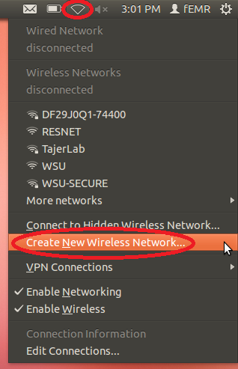

* 1. Change the network name to “fEMR” and change the wireless security to “None”

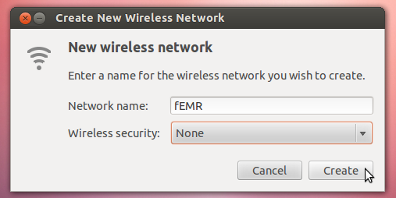

* 1. Press the internet connection button again, it may look different, and click the “Edit Connections...” button

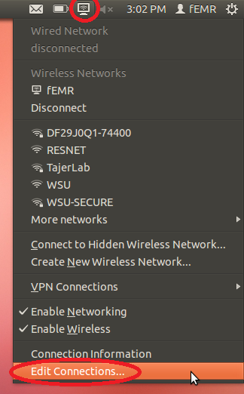

* 1. Select the “Wireless” tab, select the connection named “fEMR” and press the “Edit” button

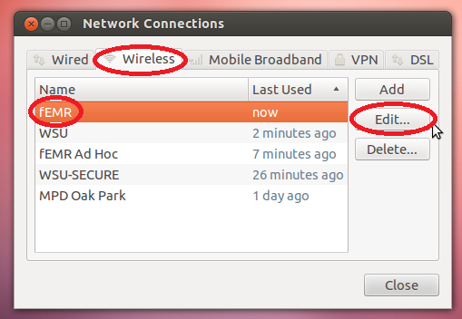

* 1. Under the “Wireless” tab make sure the mode is set to “Ad-Hoc” and band is set to “Automatic”. Under the “IPv4 Settings” tab make sure the method is set to “Automatic (DHCP)”

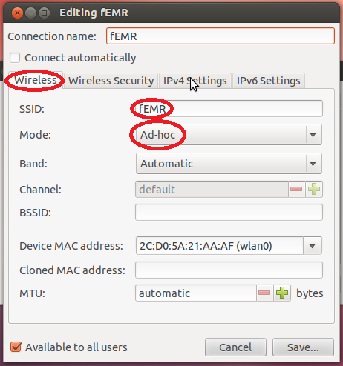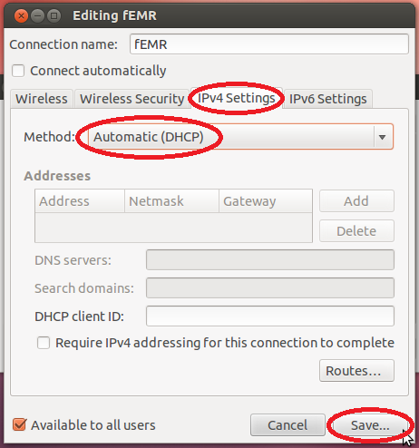

* 1. Press the “Save...” button.

1. **Starting the Ad Hoc Network**
   1. In the top right corner press the internet connection button
   2. Click the “fEMR” button.
2. **Accessing the Program**
   1. Connect to the fEMR network
   2. Open a web browser and in an address bar input the URL '10.42.0.1:9000' and press enter